How to change the index page background:
- Save your new image somewhere within ITube/New
- Open ITube/New/css/welcomeImage.css
- Change the url of the background-image to your new image
  - Remember to use “../”
- Open ITube/New/js/slideMenu.js
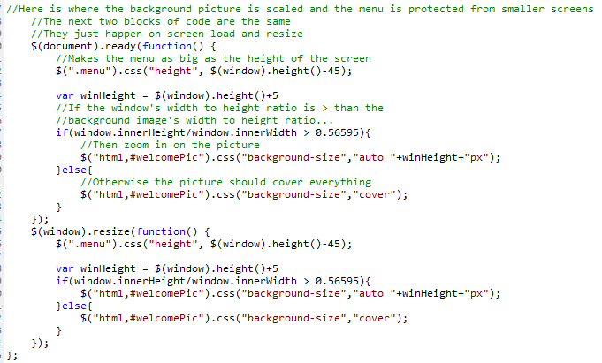
  - Look for the number in the box:

- This number is the ratio of the picture’s width to its height
  - Divide your new picture’s height by its width and put the number in the specified area.
  - This number is used to make the image scale to any sized screen.
- That’s it!

